**Experiment No. 7**

1. **Aim/Overview of the practical:**

Create a WordPress website using Azure portal.

1. **Code for practical:**

* Open and login into Azure portal with your account.
* Click on create a resource.
* Search WordPress and Select WordPress 6.0

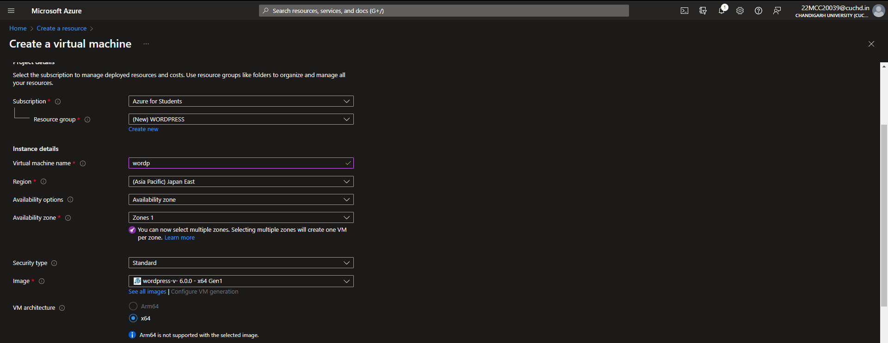

* Enter the details and select the plan for hosting.
* Select username and password and click on review + create.

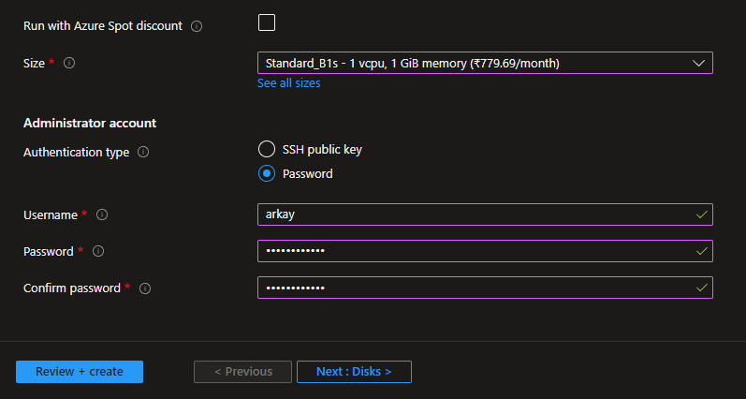

* Your WordPress website will be deployed within minutes.

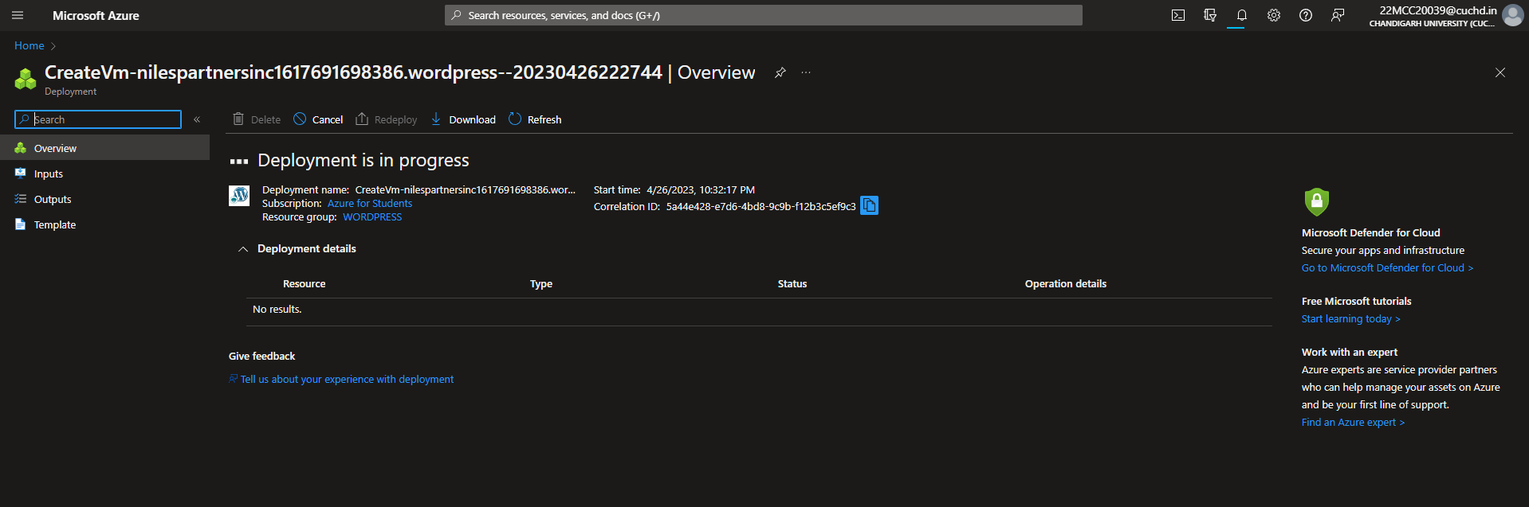

* To view your website, go to resource and click on URL,
* To access your WordPress admin panel, write /wp-admin at the end of your URL.
* Enter your Username and password for login.

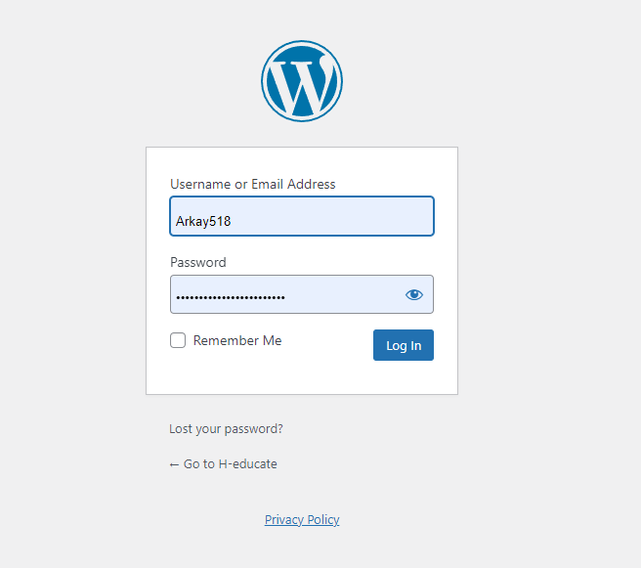

* Your admin panel of WordPress will be opened.

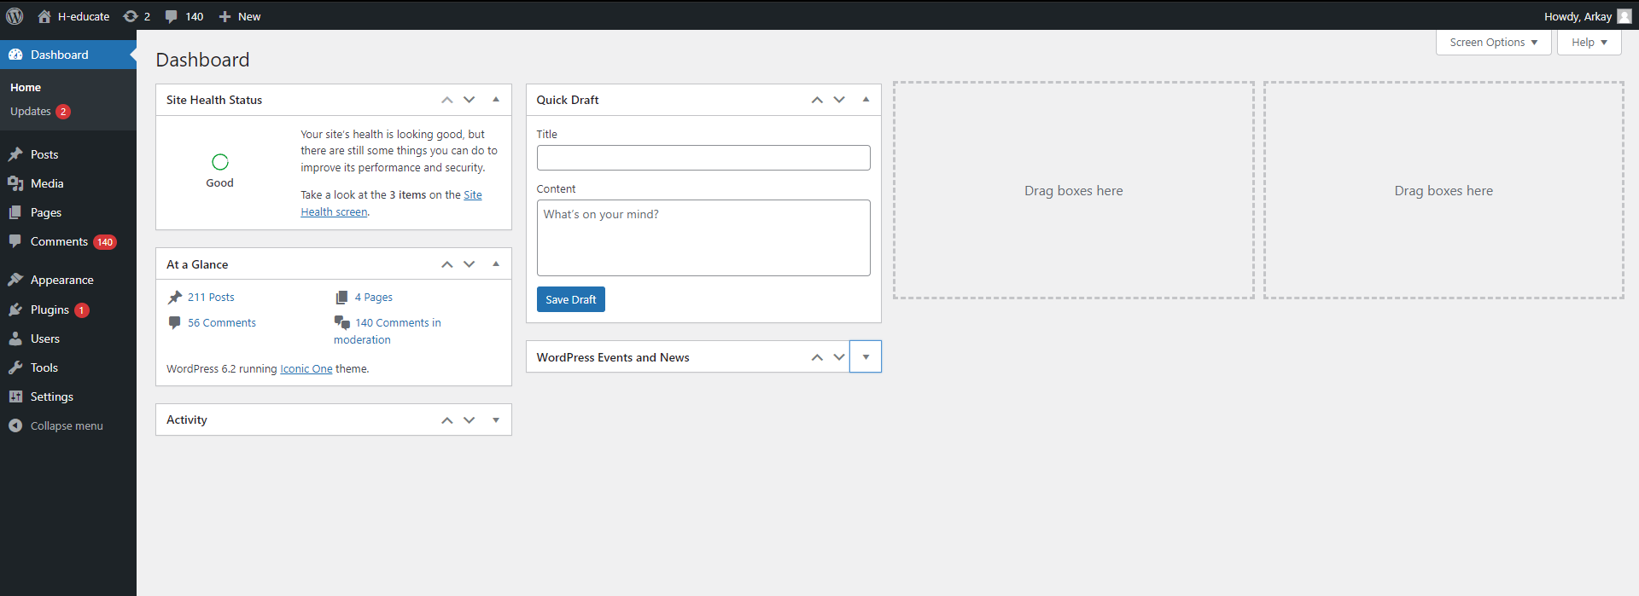

**************************************** **THE END** ***********************************************